**Project Report Template**

**TITLE: CRM APPLICATIONS THAT HELPS TO BOOK A VISA SLOT**

**1. INTRODUCTION**

* 1. **Overview**

Since 2018 was considered a huge year for CRM with all the new innovative updates keeping us on the edge of our seats. The CRM is a space optimized for all of the handheld devices. The  
service comes along with mobile configuration making it easier for you to maintain productivity  
while on the road or anywhere in the world. Finding the right CRM system platform sets a chain  
reaction that results in cost reduction, conserved time and boosted morale.

* 1. **Purpose:**

Saving the time of the customer who want to book if by using CRM applications of booking a visa slot. Wandering for booking the visa slot and tracking can be reduced here. Reduce the paper filling as much the customers expecting. Ensuring the safety of the customer and parts of many verification.

**2.Problem Definition & Design Thinking**

**2.1 Empathy Map**

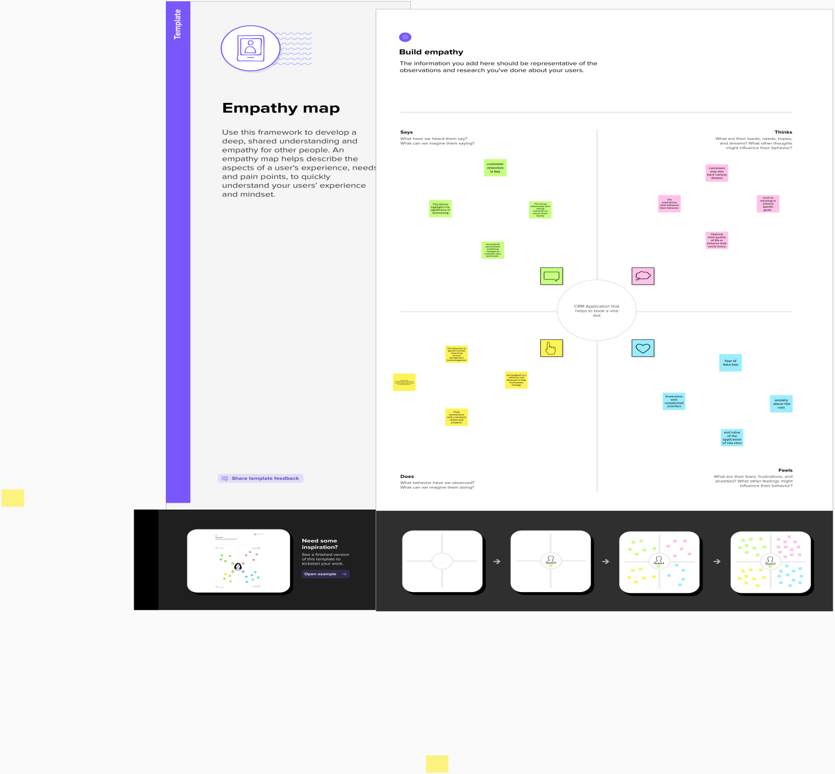

**2.2 Ideation & Brainstorming Map**

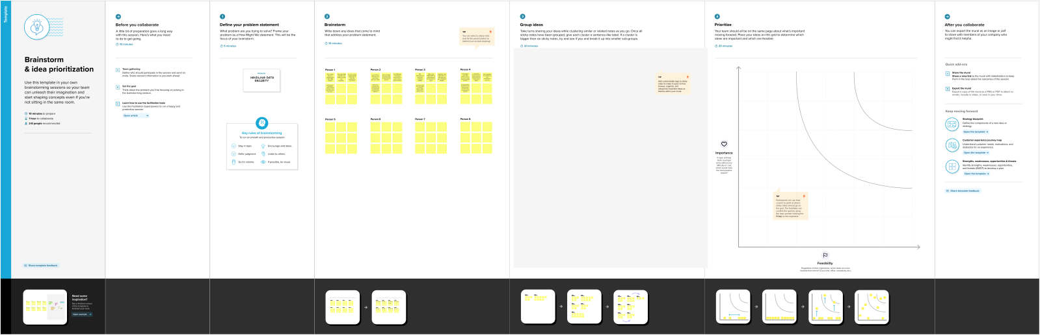

**3. RESULT**

**3.1 Data Model**

|  |  |
| --- | --- |
| **Object Name** | **Field in the Object** |
| **Passport** | |  |  | | --- | --- | | **Field Label** | **Data Type** | | contact | Number | | Full name | Text(80) | | Passport number | Text(80) | | Permanent address | Text(80) | |
| **Visa slot** | |  |  | | --- | --- | | **Field Label** | **Data Type** | | Passport Number | Master Detail | | Visa slot name | Text(80) | |
| **Labul** | |  |  | | --- | --- | | **Field Label** | **Data Type** | | Account Name | Text(80) | |

**3.2 Activity & Screenshot**

**Passport:**

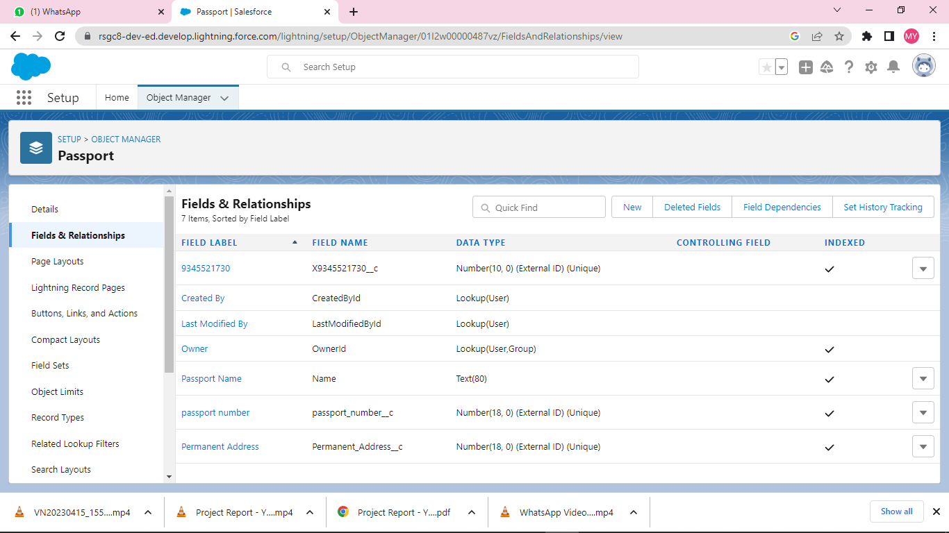

**Labul:**

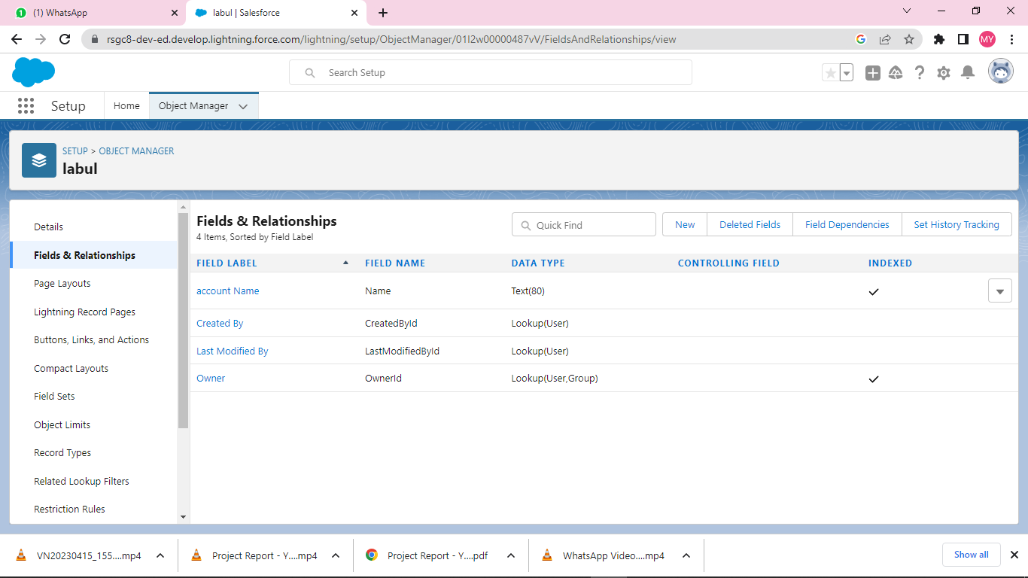

**Visa Slot:**

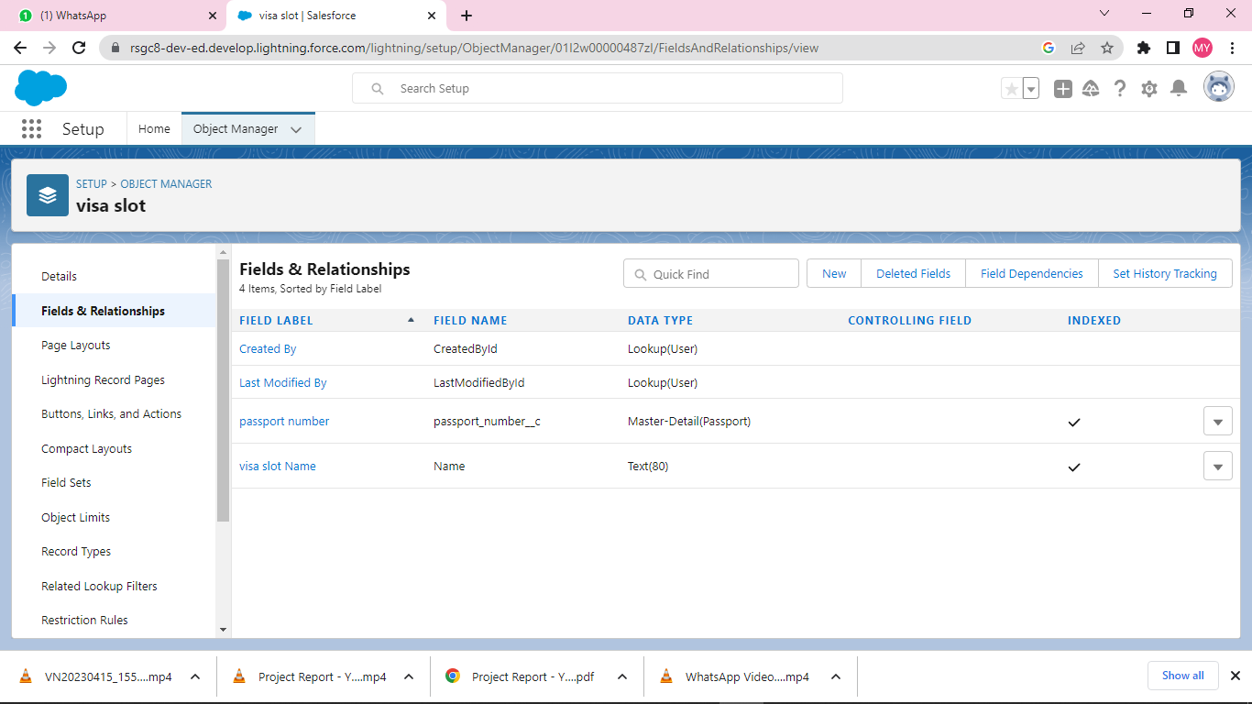

**Reports:**

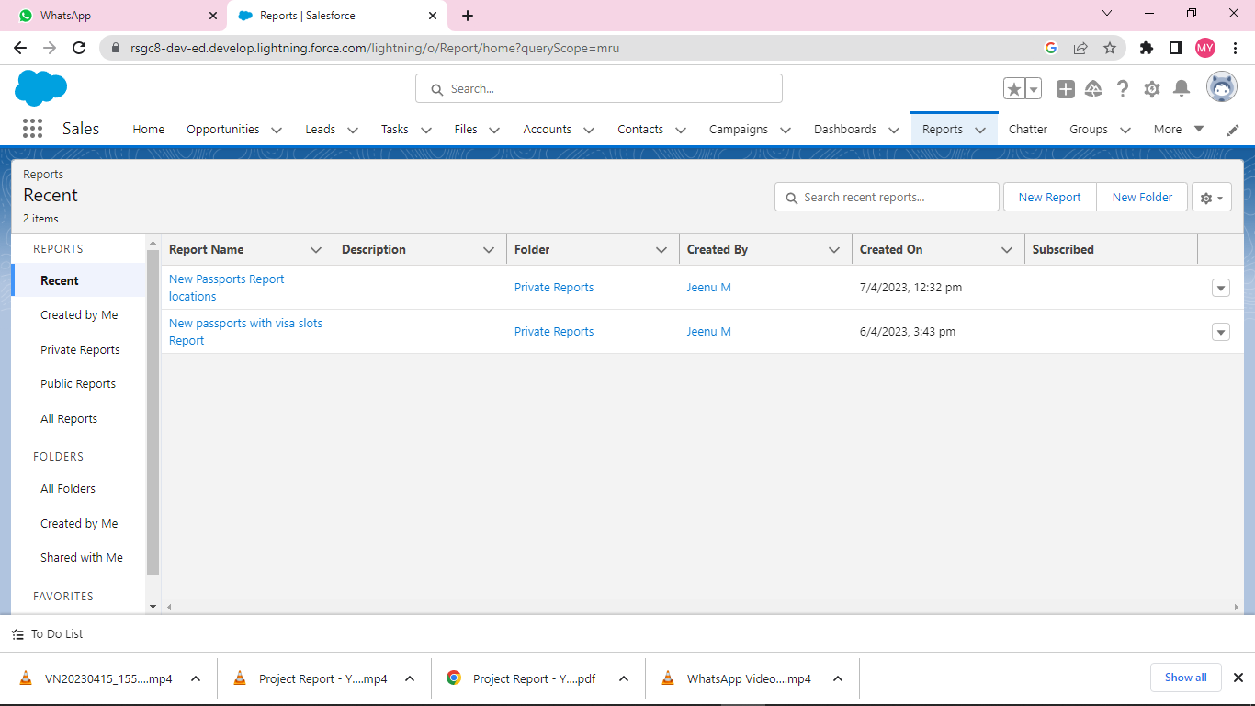

**4. Trailhead Profile Public URL**

Team Lead – Jeenu M- <https://trailblazer.me/id/jeenu18>

Team Member 1 –Rajadurai S- <https://trailblazer.me/id/rthrower1>

Team Member 2 –Karalmarks P- <https://trailblazer.me/id/kkaral8>

Team Member3 –Mukesh D- <https://trailblazer.me/id/mmukesh26>

Team Member4 –Karnan - <https://trailblazer.me/id/karnan17>

**5. ADVANTAGES & DISADVANTAGE**

**Advantages:**

* Automate the Booking of Appointments
* Reduce Your Costs
* Get Real-Time Updates
* Reduce Processing Time

**Disadvantages:**

* Can come at a cost
* Requires internet access

**6. APPLICATIONS:**

This will help you to track and manage the availability of visa slot, which are appointments that are required for certain visa applications.

CRM is a strategy employed to learn and understand customer need wants ad behaviour order to develop stronger and sustained relationship with them.

**7. CONCLUSION:**

Finally, stating your passion, willingness, and readiness to pursue your desired course at the college of your choice.

**8. FUTURE SCOPES:**

F1 Visa Slot Booking is mandatory to appear in the Visa interview before it gets approved. In addition to this, the biometrics of candidates is also a prerequisite.